
ITA0330-Mobile Computing
Name: -A Archishman Reg no: -192425341
Slot: -D Course Name: -Mobile Computing Experiment 1: Basic Cellular System Using Figma
Aim: -To create an interactive diagram illustrating the components of a basic cellular system using Figma.

Procedure

- Open Figma and create a new design file.
- Create rectangular boxes to represent the major components of a cellular system.
- Add text labels for Mobile Station, BTS (Base Transceiver Station), BSC (Base Station Controller), MTSO (Mobile Telephone Switching Office), PSTN (Public Switched
Telephone Network), and Databases.
- Arrange the components in a horizontal sequence to represent the cellular communication system.
- Use arrows between the components to indicate the direction of communication and their connections.
- Connect the Databases component to the MTSO to show its association with network information and management.
- Adjust the alignment, spacing, colors, and text formatting to make the diagram clear and readable.
- Preview the design and verify that all components and connections are displayed correctly.

Output: -

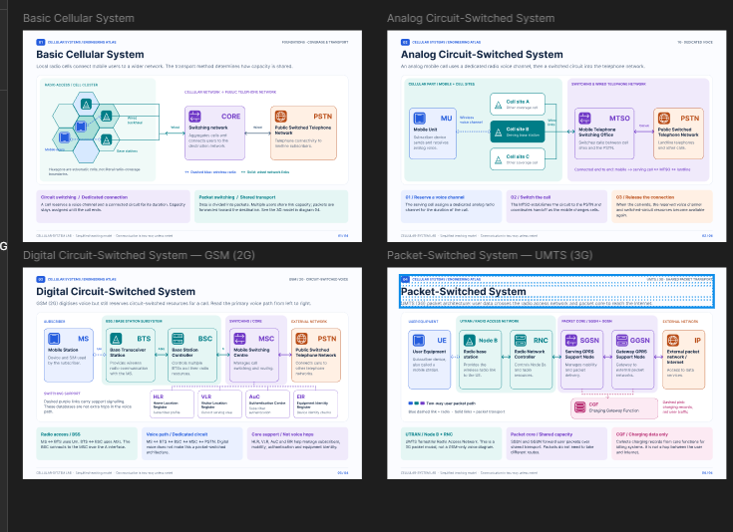

Result:-Thus, an interactive diagram illustrating the components of a basic cellular system was created successfully using Figma. The diagram represents the connections between the Mobile Station, BTS, BSC, MTSO, PSTN, and Databases.

